Semiconductor Band Gap in Silicon and Germanium Lab Report

Xiaoyang Yu

11/29/2019

**Abstract**

This experiment attempts to measure silicon band gap, as well as germanium. The experiment uses transistor p-n junction to measure the band gap. The measured silicon band gap is 1.08 ± 0.07 eV, consistent with the accepted value 1.12 eV. The measured germanium band gap is 0.39 ± 0.01 eV, not consistent with the accepted value 0.68 eV. Some internal systematical error needs to be addressed and compensated to achieve more precise measurement.

**Introduction**

Semiconductor electronic devices are widely used in every aspect of human societies. To understand how these devices works, we need to understand how transistors are integrated into these devices. To understand how these transistor works, we must know the mechanism of p-n junction. The p-n junction we make these days exists in molecular scale, thus it is the field of quantum theory. The band gap is a quantum feature exists in p-n junction (Collings, 1979). In other words, understanding semiconductor band gaps is a fundamental step to comprehend how modern electronic devices work, and how we produce them.

This experiment is an attempt to measure the band gap energy difference in the Si p-n junction, and Ge p-n junction. I will measure the energy gap in these junctions, then compare with the accepted values.

**Theory**

The current ***I*** through a semiconductor p-n junction has the following relationship with other parameters:

$I=I_{0}(e^{\frac{qV}{kT}}-1)$ (1)

Where V is potential difference between the junction, I0 is the maximum current for a large reverse bias voltage, q is the electron charge, k is Boltzmann constant, T is temperature. We need to find I0 here using this equation, which is used in further calculation to find out the energy. To find I0, we can plot a semi-log graph of ln(I) vs V. We can ignore the -1 since the exponential term is much larger than 1. Then, the interception of the semi-log plot is the value of ln(I0).

I0 has the following relationship with the energy gap we want to measure:

$I_{0}∝e^{\frac{-Eg}{kT}}$ (2)

Where Eg is the energy gap. Thus if we can measure multiple values of I0 and their corresponding T, we can find Eg by plotting log-log graph of I0 vs T-1, the slope is then -Eg/k.

However, the above relationship of I­0, Eg and T is only an approximation, more accurate relationship is this:

$I_{0}∝{T^{3/2}e}^{\frac{-Eg}{kT}}$ (3)

The term T3/2 is often negligible compared to the exponential term. Still, I will include an analysis that count in the T3/2 factor.

The above statements are made according to Collings’ paper “Simple measurement of the band gap in silicon and germanium”.

**Experiment procedure**

The experiment set up is relatively simple, the idea can be illustrated by the Figure 1, which is from the lab manual of the University of Iowa.

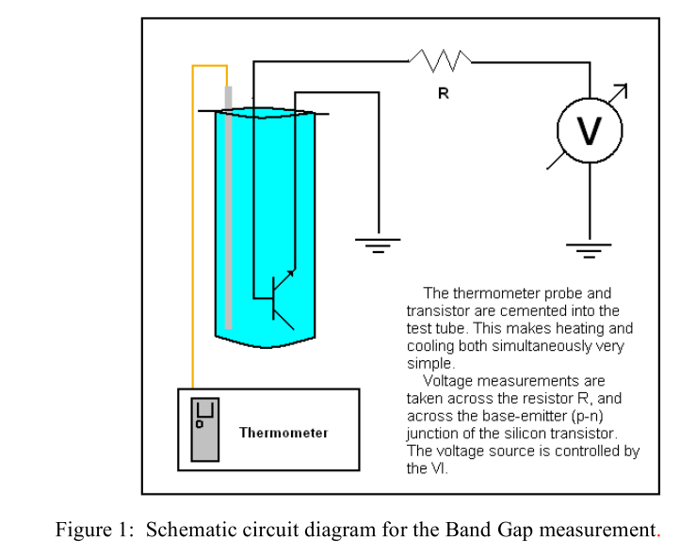

The thermometer probe and the transistor are put into a container, the container can be filled with liquid to achieve stable and controlled temperature. We use the VI system to control the voltage source. The system will also measure the voltage between the p-n junction, and the current through the junction.

With this set up, what we need to do is using the system to measure the current and voltage in a range of applied voltage, at a controlled temperature. We do this in room temperature for silicon transistor first. After we have the measured data of voltages and currents, we plot the ln(I) vs V graph, the interception will be ln(I0), as in eq(1).

Then we repeat the measurement of silicon transistor for three other temperatures. We will get a set of I0 correspond to different temperature. By eq(2), we have ln(I0) -Eg/kT. So we plot ln(I0) vs T-1 graph, the slope will be -Eg/k. We now can compare our measured Eg with the accepted value.

By now we have finished the measurement of silicon transistor band gap, we then repeat the procedure for germanium.

**Result and analysis**

The measurement of silicon p-n junction produces Figure 2, using least square fit. Since if the voltage between the junction is too low or too high, the current through the junction and the voltage will not fit eq (1), we excluded some data that obviously doesn’t fit eq (1). This would theoretically reduce some systematic error. Then we use a program to select a set of data that has a linear fit with smallest relative error on the interception. This interception value is our best guess of ln(I0), the error is the difference of maximum and minimum interception value, of all possible selections.

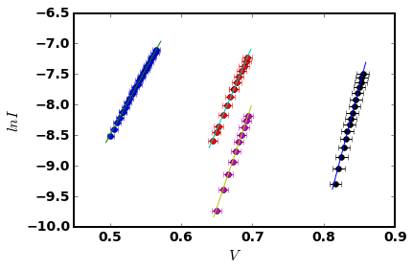

Figure 2: Measurement of silicon transistor. Each line represents a measurement in different temperature, from left to right: 374K (boiling water), 294K (room temperature), 276K (ice water mixture), 207K (dry ice).

Using the values of ln(I0) and their error, we plot the ln(I0) vs T-1 graph as figure 3, here we use least square fit against eq (2). From the slope, the corresponding band gap Eg value is 1.05 ± 0.07 eV.

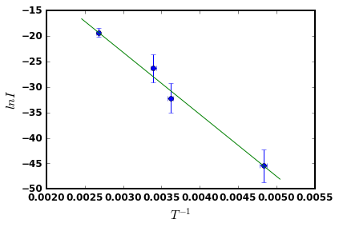

Figure 3: using eq (2) to fit ln(I0) vs T-1.

If we use eq (3) to fit the data, we got figure 4. The graph looks very much identical to figure 3, but the result Eg is slightly different: 1.08 ± 0.07 eV, closer to the accepted value.

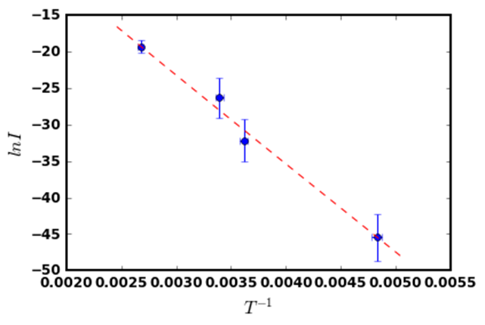

Figure 4: using eq(3) to fit the same data as in figure 3.

Similar procedure was used to measure the germanium transistor band gap, except that this time we didn’t ignore the -1 term in eq(1), so we plot ln(I) vs ln(eqV/kT-1) instead of qV/kT. Because according to Collings, the approximation eqV/kT >> 1 is not always valid for germanium. The result energy gap we got is 0.36 ± 0.01 eV if fitting the data with eq(2). Using eq(3) to fit the data, we got Eg = 0.39 ± 0.01 eV.

**Conclusion**

For silicon, the best measure of p-n junction band gap in this experiment is 1.08 ± 0.07 eV, as compared to the accepted value 1.12 eV. The accepted value falls within 1 sigma of the experiment result. For germanium, the best measure of band gap of this experiment is 0.39 ± 0.01 eV, as compared to the accepted value 0.68 eV. The accepted value falls way beyond the error range of experiment result. This implies that there has to be some internal systematical error haven’t been addressed.

The measurement of the germanium ban gap is not very successful. In my opinion, precise measurement of semiconductor band gap seems not so easy to do for an undergraduate student like me, as oppose to the conclusion made by Collings.

**Reference**

Collings, Peter. Simple measurement of the band gap in silicon and germanium. *American Journal of Physics*, 1980.

P-N junction silicon bandgap energy. The University of Iowa, 2007.

**Appendix Files**

Si_boiling.txt: raw data produced by vi, similar format for other temperatures and germanium.

Si_boiling.csv: extracted data from raw data.

fitHEP_multi_min_Si.py: python program that is used to process data.

Si_result.doc: processed result.